PCA summary

After having aggregated voxels in the 83 canonical regions (1) we decided that the best course of action would be a principal component analysis.

Our train of thought was that though the average on each region would result in a gross flattening of the activity in each of said regions, thus not allowing us to determine the specific interaction between brain regions, highly activated regions would result with high scores along the Principal Components (PC) highlighting interactions from well-established brain mechanisms.

We decided to only take into consideration regions with loadings greater than +- 2 sigma after a general subtraction of the global mean.

When interpreting the scores of the PC we must keep in mind that “Connectivity” is a stand in for Correlation, not between random variables, but between BOLD signals, which are bio-electromagnetic in nature, thus opposite signs in the scores can be interpreted either as a delay between the signal reaching two regions or as “competition” between regions.

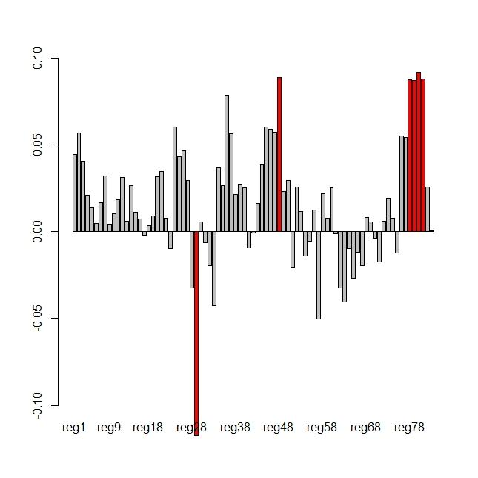

This graph represents the highlighted scores of the first PC.

Region 48 aids in the interaction between regions of the brain, sending cerebral fluid into regions where needed.

Region 29 regulates the attention redirection mechanisms

Regions 78-81 are responsible for regulating the reward and cognitive stress

INTERPRETATION:

The first PC is to be interpreted as the regular activity during the test. We can clearly see an antagonism between region 29 whose job is to regulate the specific task of switching and region 78-81 whose job is to implement optimization mechanisms on known tasks.

Whenever the subject will have to switch he will, on average, fail more often, thus having to shift their attention on the new task, and since switch-events are randomly distributed in the trial, during non-switch trials the subject’s brain will optimize to the task at hand (Free energy principle).

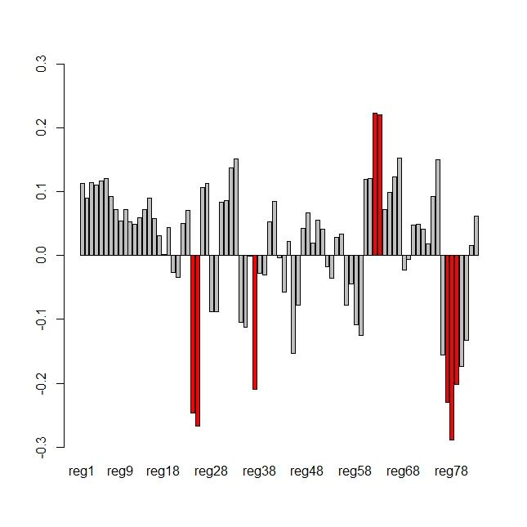

We can interpret the scores on the second PC as the brain’s normal activity.

Regions 62-63, manage hand eye coordination, it makes sense that this would be correlated negatively with regions 24-25 which are tasked in reconstructing reality from sensory input, first we reconstruct reality then we decide how to act.

And region 24-25 have se same sign correlation with regions 37 which regulates emotional response and 77-78 which as said before, regulate reward mechanisms.

This suggests that there is an emotional component in what we perceive as real, and that the more accurately we reconstruct, or we feel we have reconstructed, reality the more the brain will reward itself.

This is highly important because one of the most notable symptoms of schizophrenia is hallucinations.

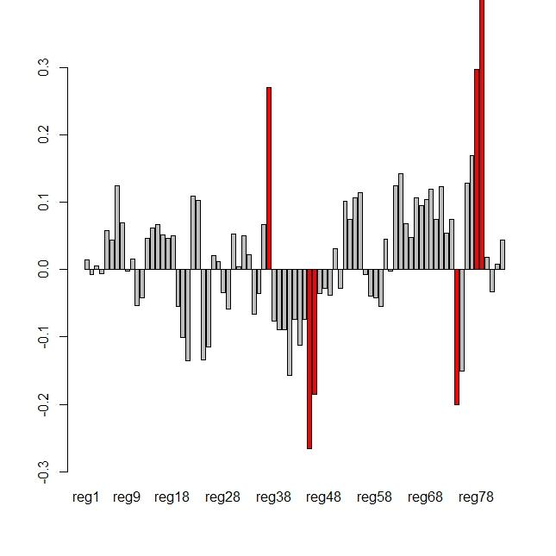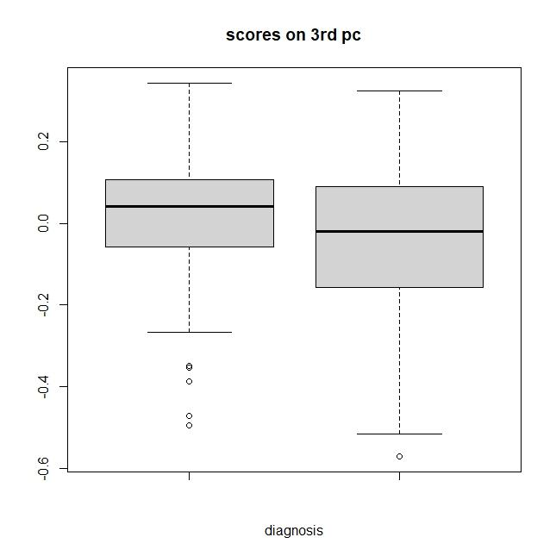

Lastly the third PC highlights the regulation of dopamine release, region 74 is not aligned the other regions which regulate the other reward systems in our brain.

This is the first PC where we can see a visible difference in the scores between neurotypical and neurodivergent subjects, lower scores in the schizophrenic population highlight an unbalanced or ineffective production of dopamine.

CONCLUSIONS:

The takeaway from this analysis is the fact that there isn’t one mechanism that distinguishes neurotypical and neurodivergent people, but it’s the interaction between several mechanisms.

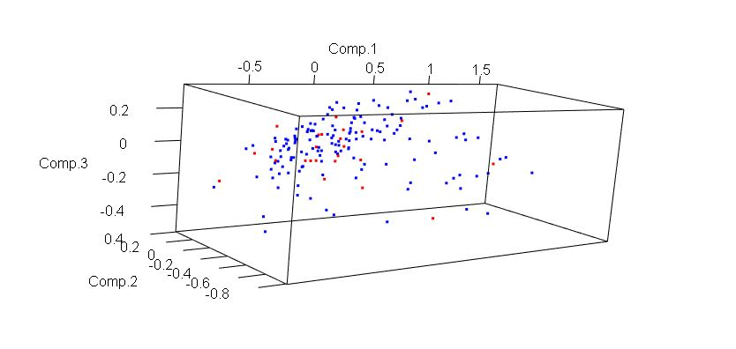

What we can highlight through a MANOVA on the scores of the first 3 PC, is that neurotypical people, tend to be less homogeneous in brain activity which is surprising since it’s the opposite result that we got from analyzing the external covariates.